Tidewater Hotel & Casino — Venue Plan
Oct 6, 2026 · @JJ
The second casino becomes the Tidewater Hotel & Casino, the Delta Circuit’s river-town casino and a regional stop on the Tour. It is a tournament venue only: no cash games run here, or anywhere else in the Delta Circuit. The Northbridge Grand plan keeps its bones (a 60-table hall, an 18-table side room, a final-table stage, an east social wing) and gains what the Game Design Bible requires: fictional names on every sign, a cage with a payout window, full tournament procedure from registration to bag-and-tag, broadcast mode and a Poker LOD budget.

Name and identity
The venue is the Tidewater Hotel & Casino, and its series is the Tidewater Poker Open. Real regional casinos are named after a place or a feature of the land (Rivers, Foxwoods, Borgata, Mohegan Sun), not after a compass point plus “Grand”. Tidewater names a river town where the tide still reaches, in one word, it reads on a marquee, and it gives the chips, the chip-set collectible and the forum nickname (“the Tide”) something to hang on.
Candidate | Reads as | Verdict
Tidewater Hotel & Casino | A riverside regional casino with rooms upstairs | Chosen
The Anchorage Casino Resort | Older, nautical, slightly tourist | Alternate if Tidewater clashes with another venue
Pier Nine Casino & Hotel | Younger, urban, converted-dock energy | Alternate if the district should feel redeveloped
Northbridge Grand | Generic; “Grand” is used by the Bible’s Mesa Grand in Neon Mesa | Dropped
Identity rules from the Bible that the plan boards broke:
- Signage carries the venue’s name only. “Short Stack” is the game’s title and never appears in the world; the boards show it on the marquee and the floor-plan header.
- “Regional Poker Series” becomes a named stop on the Tour: the Tidewater Poker Open, which awards Tour points like every regional circuit event.
- The logo is a single wave-cut “T” in brushed brass on navy. The three-word mottos on the boards (“Play / Stay / Belong”) go; real casinos run one line at most: “Tidewater. Where the river meets the game.”
- Chip set: clay chips with a navy-and-sand edge-spot pattern and a brass-foil wave inlay unique to this venue. Denominations $1 white, $5 red, $25 green, $100 black, $500 purple, $1,000 yellow, with a $5 Tidewater chip as the collectible for the chip-set wall.
- Card backs: navy with a sand pinstripe; decks are swapped at the start of every day and every flight, so a worn deck here is a tell that something is wrong.

Place in the career
The Tidewater is the Delta Circuit’s casino: a river-town hotel and casino on the levee, unlocked mid career after the first live festival. It is the player’s first road stop, a flight and a hotel bill away from home, where Tour points decide the season and the road gamblers’ mixed games live. Late in the career it hosts the Players’ Championship.
Gate | Opens | What it gives
Front doors | Mid career, after the first live festival | Sports bar, cafe, railing the hall from the concourse
Daily tournaments | The buy-in | $60–$250 dailies, the Sunday $400, the player lounge
Nightly satellites | A daily cash or a mentor’s word | The $60 step into the Open Main, the satellite room
Tidewater Poker Open | 500 Tour points, a satellite seat, or the buy-in | The regional stop, the feature table, PokerWire coverage
Events the venue hosts (fictional, like every other name in the Bible):
Event | When | Buy-in | Field | Signature
Daily deepstack | Every day, 12:00 and 19:00 | $60–$150 | 40–120 | Where regulars learn your name
Sunday Tide | Sundays 13:00 | $400 | 150–250 | Two-day; the river’s weekly major
Delta 8-Game | Wednesdays 19:00 | $600 | 30–60 | Mixed games, the road gamblers’ table
Tidewater Poker Open Main Event | Twice a year, nine days | $1,650 | 500 per flight; Day 1A and Day 1B on consecutive days | Tour points, feature table, a brass wave trophy
Open High Roller | Open week, day 7 | $5,300 | 40–80 | First time $100 chips sit in a tournament stack
Delta Mystery Bounty | Open week, day 3 | $300 | 600+ | Envelope reveal at the trophy pedestal
Step satellites | Nightly in Open week | $60 → $1,650 | 30–90 | The dream path into the Main
Players’ Championship | Once a year, late season | $50,000 | 100 | 8-game mix; the Bible’s prestige event, with its final table on the Tidewater stage
The Open is where the Bible’s tournament realism shows in full: starting flights, late registration, bag-and-tag, a Day 2 redraw, hand-for-hand on a bubble that pays about 15% of the field, and a final table played on the stage under broadcast lights.

Ground floor, revised
The master plan’s layout stands: lobby and security vestibule at the south entrance, registration concourse behind it, satellite room west, tournament hall north, social wing east, back of house along the east and north walls. The footprint of about 145 m by 105 m stays. What changes is what each zone does, so a player can walk through a tournament day the way the Bible describes: register at a window, find the seat card, rail the feature table from the stands, and collect a payout at the cage.
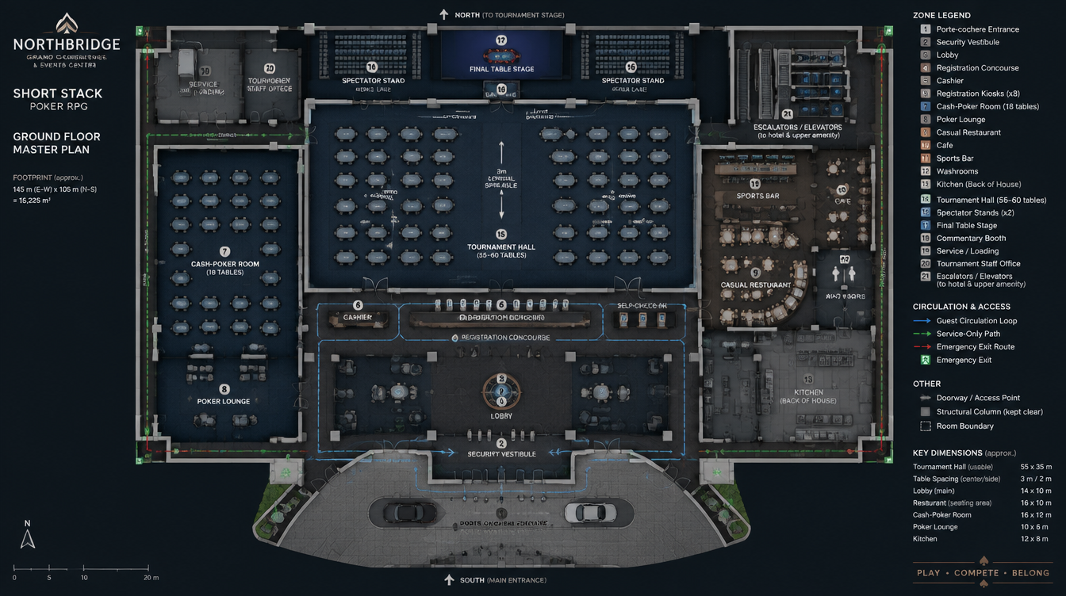
Zone (plan number) | As planned | Revised to standard
Porte-cochère and security vestibule (1, 2) | Entrance, security desk | Same. Security remembers barred players; the walk-home robbery risk from the Bible starts at these doors after the last satellite breaks.
Lobby (3) | Welcome desk, mottos on the floor mats | Hotel check-in and concierge. One brass Tidewater wave inlaid in the floor, no slogans. Hotel elevators (21) sit here, so the festival-week hotel bill is a real walk.
Registration concourse (4) | Eight kiosks, cashier, schedule board | Four kiosks plus two staffed windows (real rooms queue at windows during Open week). Schedule board shows blinds, entries and prize pool live. A late-registration countdown is visible from the lobby.
Cage (5) | Cashier | Renamed the cage. Takes buy-ins over the counter, pays tournament payouts at a separate payout window with ID, holds player lockers (safety-deposit boxes) and the player’s card for comps.
Satellite room (7) | 18-table cash room, 16 m by 12 m | 18 tables, enlarged to 20 m by 14 m so tables sit on 3 m centres. Runs the nightly step and mega-satellites, the noon daily when the hall is dark, and side events during Open week. Its own clock screen and a registration window at the door.
Player lounge (8) | Lounge | A quiet room with the clock screens repeated, so a player on break can eat and study on the phone. Railbirds and busted players gather here.
Tournament hall (15) | 55 to 60 tables, 3 m centre aisle | 56 tables in four sections (A to D, 14 each) plus a four-table overflow bay. Clock screens every two sections, a chip-count feed, a redraw board by the TD office, a bag-and-tag station at the north end.
Final table stage and spectator stands (16, 17) | Raised stage, two stands of about 60 | Same seats. Add the hole-card camera rig, delayed broadcast wall, commentary booth glass, a standing rail and the trophy pedestal where mystery-bounty envelopes are opened.
Media corridor and back of house (18, 19, 20) | Commentary booth, TD office, staff office, service and loading | Same, with the ready room (lockers and water) for feature-table players and a staff break room the player can only reach with a staff friend.
Casual restaurant, cafe, sports bar (9, 10, 11) | East social wing | Same. The sports bar is where prop bets and NPC gossip live; the cafe is the dinner-break refuel and the late-satellite refuel. The kitchen stays back of house.
Washrooms and ATM (12) | Present | Same. The ATM is a Bankroll-discipline trap: using it on tilt to re-enter costs Composure.
The remaining boards, kept as reference. The art direction (navy, brass, dark timber, wet-look stone) matches the Delta palette (river timber, brass, navy, a humid haze in the lights) and stays; only the lettering changes.
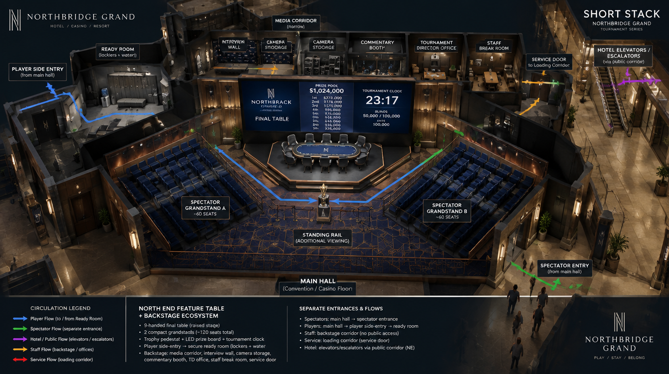
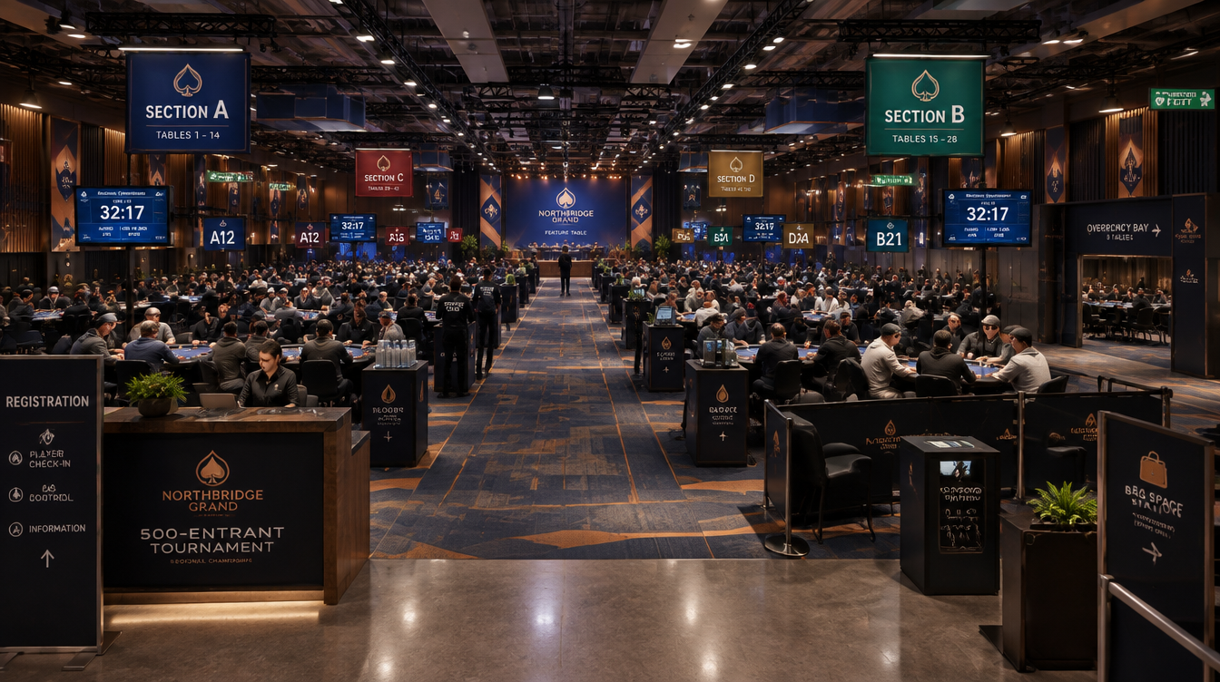
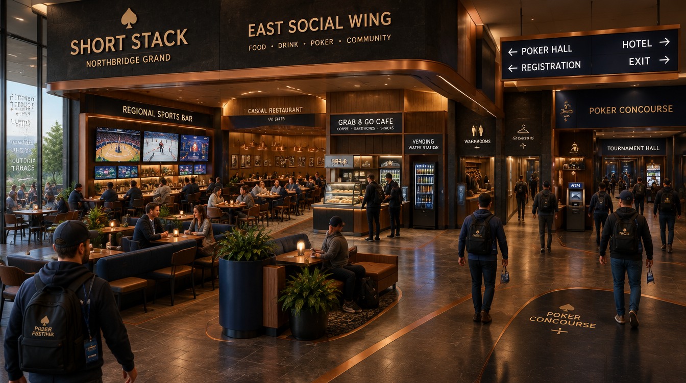
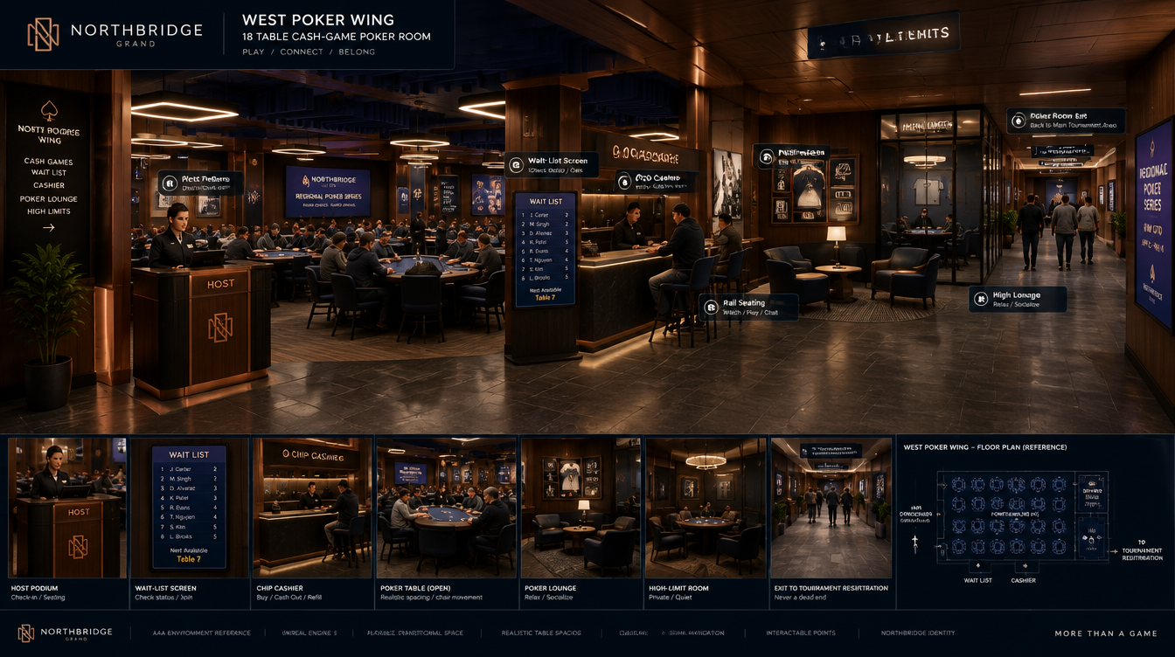
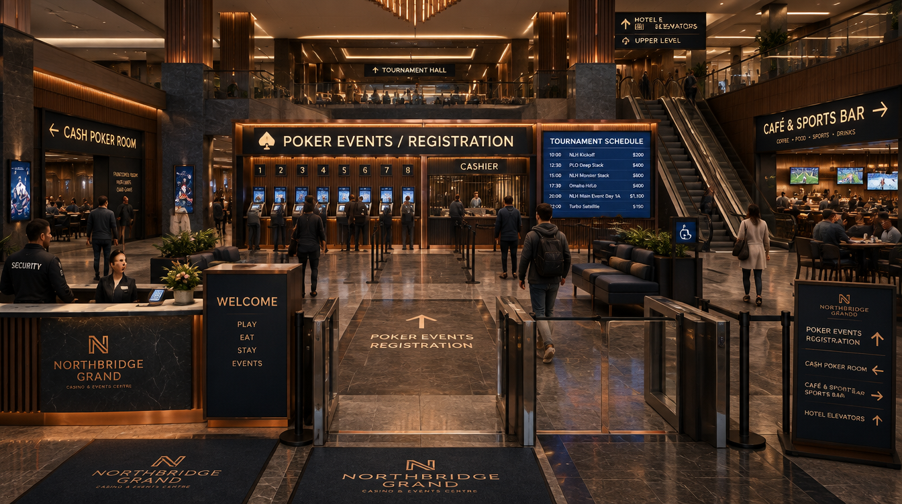

Tournament hall and feature table
The hall runs a real tournament day end to end, on the C++ tournament director the Bible already specifies, so nothing here is a new system: it is the first place the player sees all of it at once.
A flight, in order:
- Register at a window or kiosk; the seat card prints with table and seat (A12, seat 4). Late registration runs through level 8 with one re-entry per flight.
- Find the section by the hanging sign and the table by the number stand. A floor person walks the aisle and answers rulings on the fictional rulebook: verbal action binding, string bets, the one-chip rule.
- Levels of 40 minutes in the dailies and 60 minutes in the Open, with a big-blind ante, a break every two levels and a 60-minute dinner break that sends the whole room to the east wing.
- Table breaks and balancing move players by the director’s logic; the move is a walk, not a cut, so the player sees the room thinning.
- Colour-up and chip race at the end of the $25 and $100 chips.
- Bag-and-tag at the north station at the end of a day: count, bag, sign, and your count appears on the live chip-count feed and on PokerWire.
- Day 2 redraw on the board by the TD office. Hand-for-hand on the bubble at about 15% of the field paid. Payouts at the cage’s payout window with ID.
The feature table. The stage is the Bible’s broadcast mode made physical:
- Nine-handed raised stage with hole-card cameras under the rail, a 30-minute delay on the broadcast wall, and commentary from the glass booth driven by engine events: stack depth, pot odds, history between the players.
- Two stands of about 60 seats and a standing rail; friends and rivals who busted sit in them and the player can see who turned up.
- A heart-rate readout for every finalist, driven by Composure, shown on the broadcast wall.
- The ready room behind the interview wall is where the final-table walk-on starts; the lighting change and the trophy ceremony run on Sequencer.
- PokerWire sends a reporter for the Open final table, so what happens on this stage is what the forum remembers.
Sizing check. The hall’s usable 55 m by 35 m is about 1,925 m²; 60 tables on 3 m centres with the central aisle use about 900 m², which leaves room for the stage, both stands and a clear fire aisle along each long wall. One 500-entry flight fills 56 tables at nine-handed; one flight per day, Day 1A then Day 1B, plus re-entries puts the Open Main at 900 to 1,100 entries, which is the right size for a regional stop two rungs below the 10,000-player Crown Main.

Living-world hooks
The Tidewater runs on the Bible’s real rhythms, so the same building plays differently by day, hour and season.
When | What the room looks like | What it means for the player
Weekday afternoons | The noon daily draws 40, retirees and online grinders on a break | Tight, cheap, good for Study-Lab homework between hands
Friday payday and Saturday night | The 19:00 daily sells out, hotel guests, sports-bar spillover | The softest fields of the week; re-entries pile up
Sunday | The Sunday Tide fills half the hall | Where a local first makes a name on PokerWire
Rainy nights | Locals who stayed in town fill the satellite room | Extra satellite flights, the lounge is full, rumours travel fast
Big sports weekends | Tourists in the dailies, drunk by 11 p.m. | Soft money with a whale-fun meter to protect
After 2 a.m. | The last satellite breaks, the hall goes dark, security thins out | The walk along the levee to the hotel is the risk, not the game
Open week, twice a year | Every table in use, hotel full, media corridor live | Festival life: 12-hour days, swaps, rail sweats, a party that costs Stamina
Rumours that point here (delivered by phone, forum and the sports bar): “The Tuesday satellite is full of hotel guests who have never seen a Day 2.” “Big Sal booked the hotel for Open week.” “Nitro is registered for the Sunday Tide.”
Who lives here:
- Duke Marlowe is the regular here. The Delta is his circuit: he plays the Wednesday 8-Game and the dailies, holds court at the sports bar, and his read on your bust-outs is the mentor thread for reads and integrity.
- Big Sal Ricci stays in the hotel for every Open, fires every daily and re-enters until the window closes. His fun meter decides whether he comes back next Open and brings his friends.
- June Albright comes down from Harbour Point for Open week with the home-town crew. Her nod is what makes the Delta regulars treat the player as one of their own.
- Mika “Nitro” Vance first appears across the table at the Sunday Tide; the first big pot between you is the rivalry trigger the Bible describes.
- Teo Park rails from the stands at your first feature-table run and swaps 10% with you in the lounge.
What the venue writes to the world. PokerWire reports Open results and the feature table; The Rail argues about the bubble; the chip-count feed and the bubble generate news on their own. Every hand in the hall goes into the same public event stream, so the memory system, the forum and the achievements all see the same thing.

UE5 build notes
The Tidewater is one World Partition cell in the Delta Circuit’s river-town district, built from the same kit as the first casino so the second room costs a fraction of the first.
Poker LOD in the hall. The Bible’s simulation tiers map onto the floor plan directly, and the hall is the first place all four tiers run at once.
Tier | Where in the building | Simulation | Rendering
0 | Your table, and the stage when you are on it | Full engine, full AI, real time | Full MetaHumans, Control Rig hands
1 | The four tables around yours and the feature table | Full engine, archetype AI | Low-cost animation, visible chips
2 | Any table holding a named NPC, anywhere in the hall or satellite room | Full engine headless on worker threads | None; Mass Entity crowd stand-ins
3 | Every other table, and the whole building during a time skip | Statistical chip-flow per level | Mass Entity silhouettes only
Environment.
- Lumen for the hall’s emissive section signs, clock screens and broadcast wall; hardware ray-traced reflections on the lobby stone and the stage’s lacquered rails at high settings.
- Nanite for the brass, timber and stone kit; one PCG graph dresses all 60 tournament tables (table, nine chairs, number stand, chip trays) from the section layout, so a daily with 12 tables and an Open flight with 56 come from the same graph.
- HLODs for the hall seen from the lobby doors; the east wing and back of house stream separately.
- Crowds: Mass Entity for the concourse, stands and rail, with seated agents that react to the broadcast wall (a groan on a bad beat is audible from the concourse).
Materials and props unique to this venue.
- Tidewater clay chips with the navy-and-sand edge spots and brass wave inlay; chip stacks instanced, switching to Chaos physics only when a pot is pushed or a stack is knocked over on tilt.
- Navy felt with a tighter weave than the home card room’s worn green; the difference should read in the first close-up.
- River mist on the porte-cochère glass and a humid haze in the lobby lights, since this is the Delta.
Audio.
- MetaSounds room tone scales with occupancy: six tables at 3 p.m. sounds like a library, 56 tables at level 4 sounds like a stadium concourse.
- The sports bar bleeds through the east doors; the broadcast commentary bleeds through the stage doors on a delay.
- The floor’s break and seat-open calls over the hall PA are real audio cues the player can hear from the lounge and the cafe.
Pipeline. Chips, card backs, the number stands, the trophy and the lobby wave come from Blender through the existing batch export; the signage text lives in a data table so a rename never touches a mesh.

